QUESTION 507 : https://leetcode.com/problems/perfect-number/submissions/2190735590/

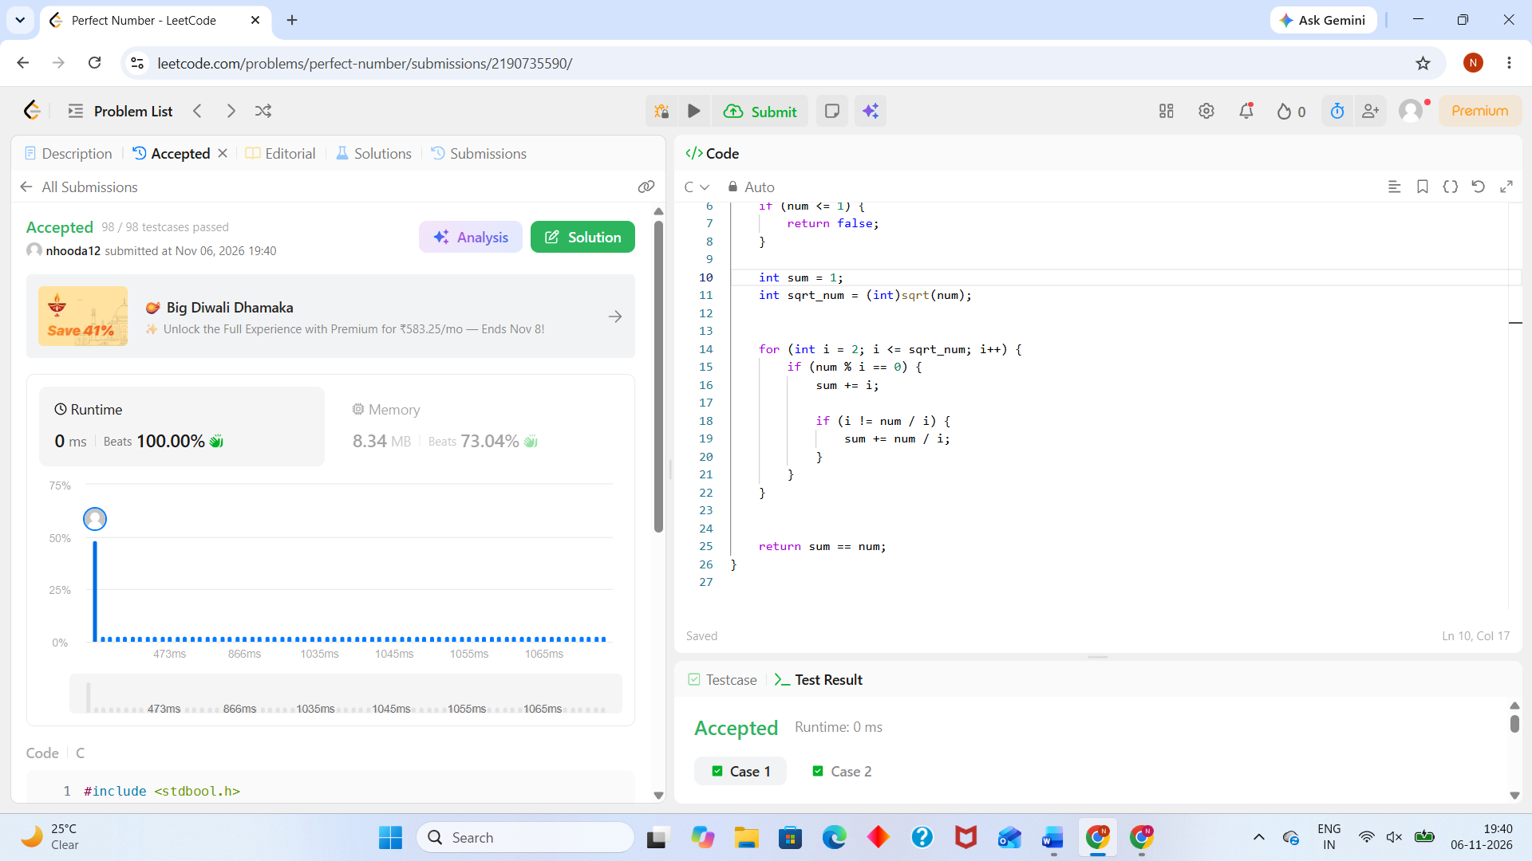
#include <stdbool.h>
#include <math.h>

bool checkPerfectNumber(int num) {
// Perfect numbers must be greater than 1
if (num <= 1) {
return false;
}

int sum = 1;
int sqrt_num = (int)sqrt(num);

for (int i = 2; i <= sqrt_num; i++) {
if (num % i == 0) {
sum += i;

if (i != num / i) {
sum += num / i;
}
}
}

return sum == num;
}

